REPORTING SALES IN PARAGON

Did you know that you can report your own sales in Paragon? You no longer need to send a status change form to the MLS in order for sales to be reported. If you have access to input and update your listings, you also have access to report sales. Please make sure that you are reporting them correctly with the selling broker being the broker representing the buyer. Remember status changes must be reported by the next business day.

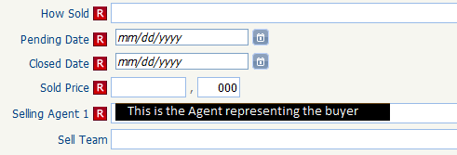
* * * * * * * * * * * * * * * * * * * * * * * * * * * * * * * * * * * * * * * * * * * * * * * * * * * * * * * * * * * *

Individual Agent Charges

Individual agents are billed for the following services:
Listing input by the MLS staff: $6.00 each
Listing changes by the MLS staff: $6.00 each
Duplicate listings: $5.00 for each additional listing

An invoice will be emailed to each agent. The charges are due 30 days from the invoice date and are subject to a late penalty. These fees have been in place since 2002.

* * * * * * * * * * * * * * * * * * * * * * * * * * * * * * * * * * * * * * * * * * * * * * * * * * * * * * * * * * * *


RPR Available to You!
The Realtor Property Resource (RPR) is a FREE website that combines public record data and MLS data in one place for you. Visit www.narrpr.com to create your free account. After you create your account, make use of their mobile solution at m.narrpr.com.
Click to view the webinars currently offered including RPR for New Members, Finding the Best Fit for First Time Homebuyers, and Drill Down & Zone In With RPR Property Searches

