HOLIDAY HOURS
The SAR/MLS will be closing at noon on Friday, December 30, 2022 and will be closed on Monday, January 2, 2023, in observance of New Year’s Day. We wish you and your staff a safe and happy holiday.
* * * * * * * * * * * * * * * * * * * * * * * * * * * * * * * * * * * * * * * * * * * * * * * * * * * * * * * * * * * *
CLOSED SALES DEADLINE
Cutoff for 2022 closed sales will be Wednesday, January 4, 2023 at noon. All sales and corrected sales must be entered into the MLS by this date and time in order to be reported for 2022.
* * * * * * * * * * * * * * * * * * * * * * * * * * * * * * * * * * * * * * * * * * * * * * * * * * * * * * * * * * * *
DO YOU NEED AN EASY WAY TO CHECK YOUR SALES FOR THE YEAR?
Go to Resources and select Statistical Reporting. In the Statistical Reporting Area, go to the Sales Detail section under Broker. This will bring up of your sales (listing or sale side) that were reported in 2022. Participants (firm brokers) are able to view this report for all agents/brokers in their office.

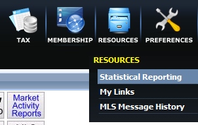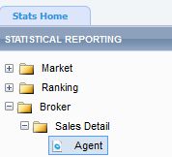
* * * * * * * * * * * * * * * * * * * * * * * * * * * * * * * * * * * * * * * * * * * * * * * * * * * * * * * * * * * *
REPORTING SALES
Contingent to Pending – Remember that if you report a property as contingent, you need to change the status to pending once the contingency has been removed. A contingent sale is still an active status, so if a property has a contingent status, and the expiration date is prior to the sale closing, it will automatically expire. They will also continue to accumulate Days on the Market (DOM) until changed to Pending. Pending listings remain pending until they are reported as sold or put back on market.
Correct MLS numbers - Please check to make sure you have the correct MLS# on your forms before submitting them to the MLS. Many Status Change Forms are being sent in with the wrong MLS#’s on them.
Expired Listings - Once a listing has expired it can not be changed to Sold Closed unless it went Pending prior to it expiring. If it has, please make sure to put the Pending date on the MLS Status Change form when sending in the Sold information.
Financing and Additional Agents - When sending in your closed sales please remember to check off the type of financing. Also, if there are any additional listing agents or sales agents, please be sure to list them down below the sale information in the spaces provided.
Reporting Duplicates as Sold - Make sure to include both MLS numbers when reporting a duplicate listing as sold closed. MLS will make one of the numbers sold and the other one will be deleted from the system.

